**SEU/IS/22/ICT/041**

**Subject code** : CIS11051

**Subject :** Practical of Database design

**Title:** Mysql Joins

Department of Information Communication And Technology

Faculty of Technology

Southeaster University of Sri Lanka

Exercise 1:

1. Create a database named Lab10_Part1 and tables named Employees and Projects as shown below.

 Database Creation:

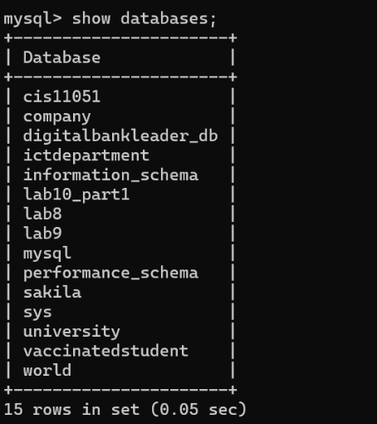

**Employees table:**

# Column Name Constraints

|  |  |
| --- | --- |
| *emp_id name department salary age* | Primary key |
| Nullable |
| Nullable |
| Nullable |
| Nullable |

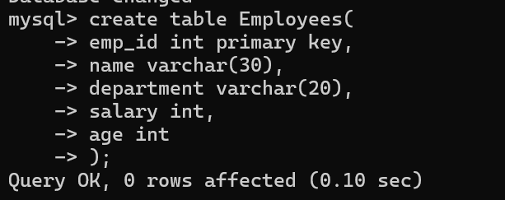 Code:

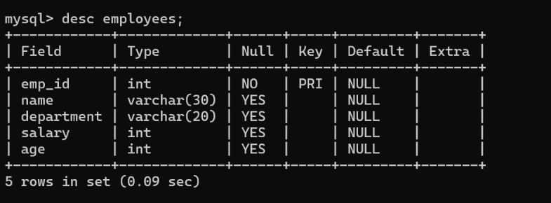

O

**Projects table:**

# Column Name Constraints

|  |  |
| --- | --- |
| *project_id emp_id project_name duration_months* | Primary key |
| Nullable |
| Nullable |
| Nullable |

Code:

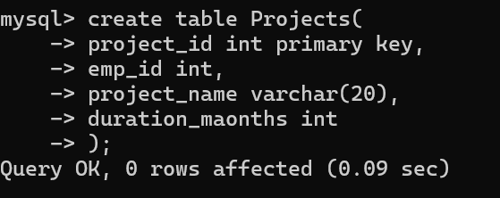

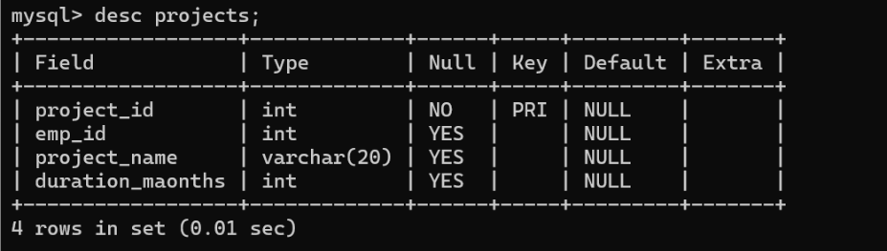

**Employees table:**

|  |  |  |  |  |
| --- | --- | --- | --- | --- |
| **emp_id** | **name** | **department** | **salary** | **age** |
| 101 | Alice | HR | 50000 | 30 |
| 102 | Bob | IT | 60000 | 28 |
| 103 | Charlie | Finance | 55000 | 32 |
| 104 | Diana | IT | 60000 | 28 |
| 105 | Eva | Marketing | 48000 | 27 |
| 106 | Frank | Finance | 53000 | 35 |
| 107 | Grace | HR | 50000 | 30 |

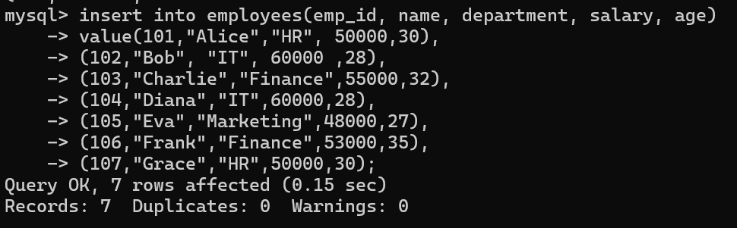 Code:

**Projects table:**

|  |  |  |  |
| --- | --- | --- | --- |
| **project_id** | **emp_id** | **project_name** | **duration_months** |
| 201 | 101 | Onboarding App | 6 |
| 202 | 102 | E-commerce Site | 12 |
| 203 | 103 | Payroll System | 9 |
| 204 | 108 | CRM Platform | 10 |
| 205 | 106 | Audit Tool | 4 |
| 206 | 101 | Employee Survey | 3 |
| 207 | 109 | Marketing Portal | 5 |

Code:

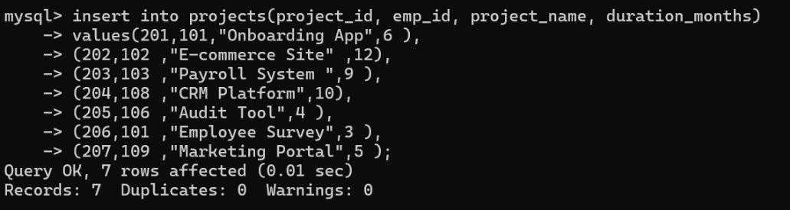

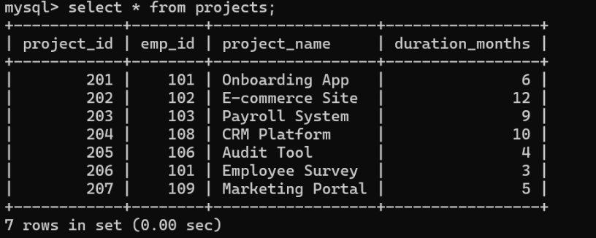

**Section A – INNER JOIN Focus**

1. List all employees’ names who are working on a project along with the project name.

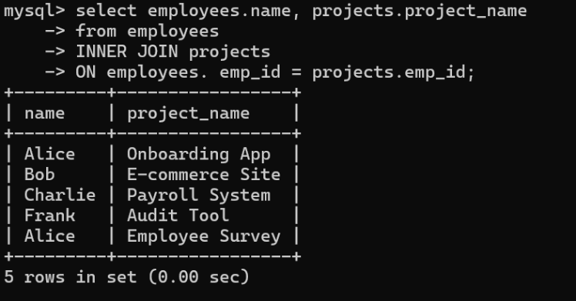Code:

1. Show all projects names with a duration greater than 6 months along with the corresponding employee names.

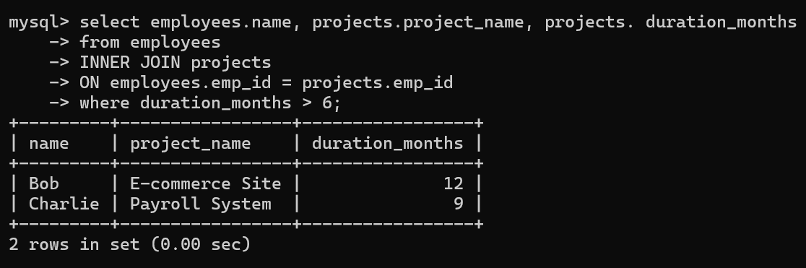Code:

1. List employee names and project names where the salary is more than 55000.

Code:

**Section B – LEFT JOIN Focus**

1. Display a list of all employee’s names and their assigned project names.

Code:

1. List the names of all employees and their project names if any, but only for employees whose age is between 28 and 32.

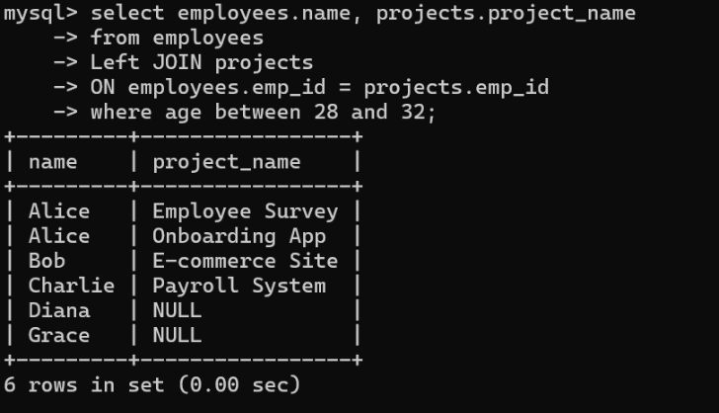Code:

**Section C – RIGHT JOIN Focus**

1. Show all project names and their assigned employee names.

Code:

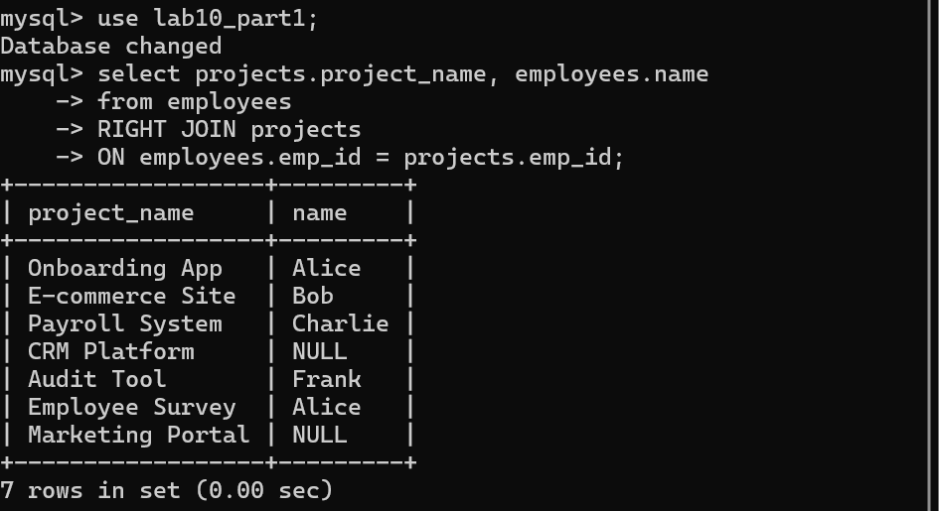

1. Display all project names and employee names (if assigned), where the project duration is more than 5 months OR the employee's salary is less than 55000.

Code:

**Section D – CROSS JOIN Focus**

1. Create a cross combination of all employees with all project names (Cartesian product).

Code:

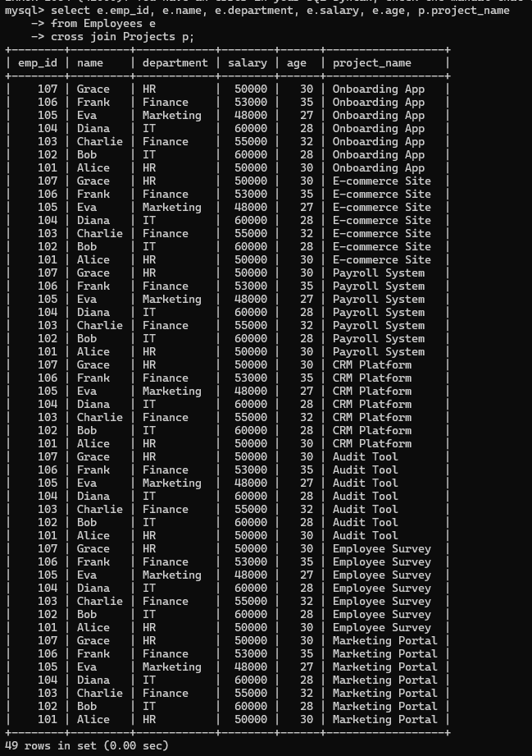

1. How many total combinations exist between employees and projects? Use aggregation.

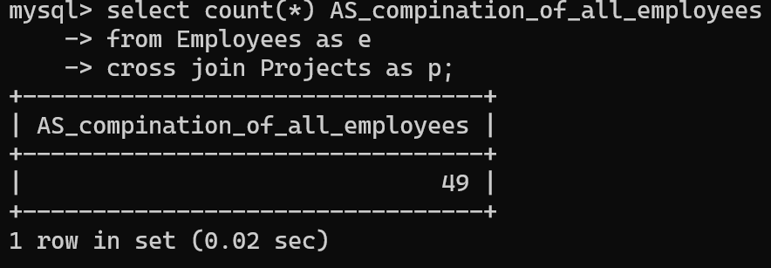

**Section E – Mixed Concepts**

1. Find the average salary of employees in each department who have at least one project.

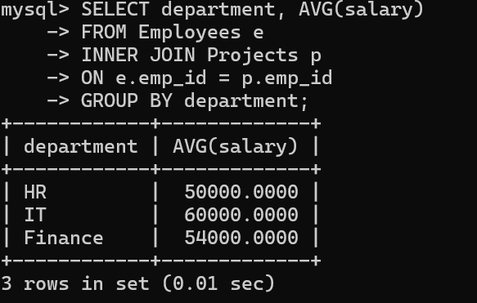Code:

1. Find the number of employees with duplicate salaries and show their salary and count.

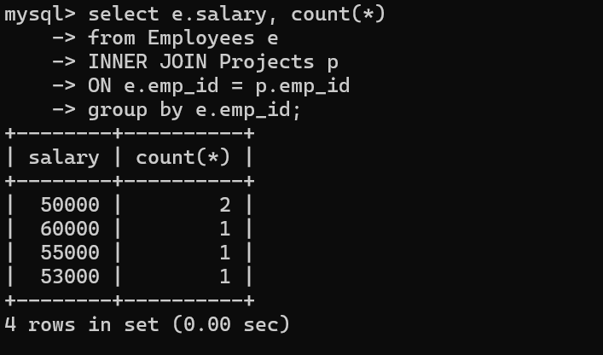Code:

1. Show the project names and corresponding employee names (if available), but only for projects assigned to employee IDs in (101, 103, 109).

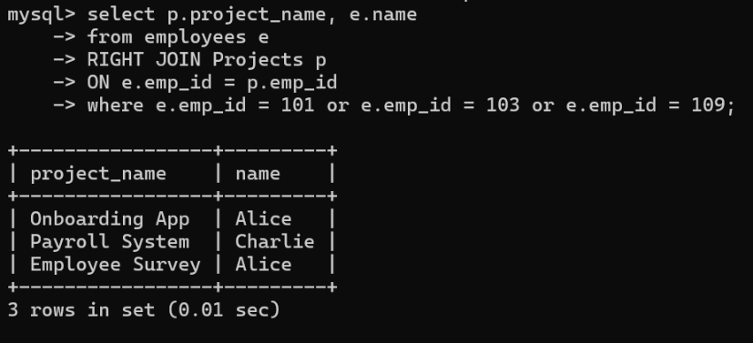Code:

**Exercise 2 (ADVANCE):**

1. Create a **database** called **Lab10_Part2** with two **tables**: **Customers and Orders**. Insert the given records using **appropriate data types**, establish a **foreign key relationship** between the tables, and use **INNER JOIN** in the queries to **retrieve the required results**.

Database creation:



**Table: Customers**

|  |  |  |  |  |  |
| --- | --- | --- | --- | --- | --- |
| **CustomerID** | **CustomerName** | **ContactName** | **Address** | **City** | **Country** |
| 1 | Green Valley Farms | John Smith | 101 Maple Street | New York | USA |
| 2 | Oceanic Foods | Emma Johnson | 202 Ocean Drive | Los Angeles | USA |
| 3 | Sunny Cafe | Daniel Brown | 303 Sunset Blvd | Miami | USA |
| 4 | Tech World | Lisa Williams | 404 Tech Ave | San Jose | USA |
| 5 | Happy Pets | James Davis | 505 Pet Lane | Chicago | USA |
| 6 | The Book Nook | Sophia Miller | 606 Library Road | Boston | USA |
| 7 | Gourmet Market | Benjamin Wilson | 707 Gourmet Street | Houston | USA |
| 8 | Travel Experts | Olivia Martinez | 808 Travel Blvd | Seattle | USA |
| 9 | Bloom Florists | Alexander Garcia | 909 Rose Avenue | Denver | USA |
| 10 | Fast Fix Repairs | Charlotte Anderson | 1001 Fixer Street | Atlanta | USA |

**Table creation:**

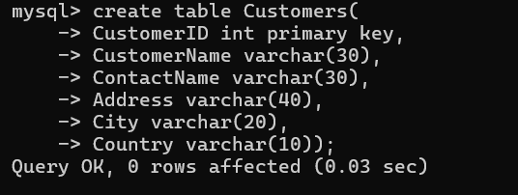

**Inserting Details:

**Table: Orders**

|  |  |  |
| --- | --- | --- |
| **OrderID** | **CustomerID** | **OrderDate** |
| 10248 | 9 | 7/4/2022 |
| 10249 | 8 | 7/5/2022 |
| 10250 | 3 | 7/8/2022 |
| 10251 | 8 | 7/8/2022 |
| 10252 | 7 | 7/9/2022 |
| 10253 | 3 | 7/10/2022 |
| 10254 | 1 | 7/11/2022 |
| 10255 | 4 | 7/4/2022 |

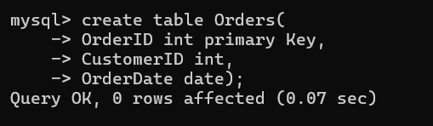 Table creation:

Describe Table:

Inserting Details:

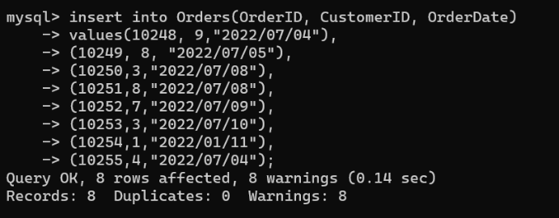Code:

Foreign key :

Out 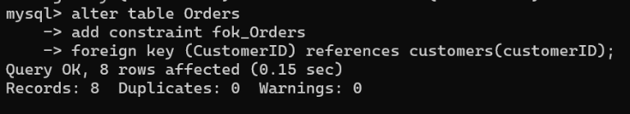Output

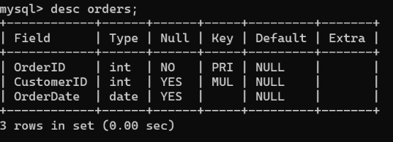

1. Show the details of customer ID, customer name from customer table, orderID and order date, only who made orders. And sort them by the customerID in ascending order.

Code:

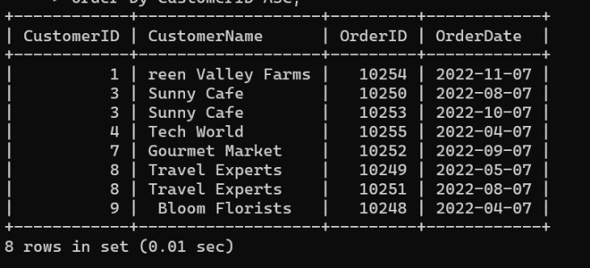

1. Display the customer details who made orders on after July10,2022.

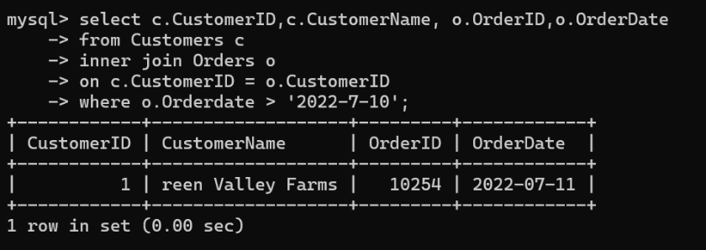Code:

1. Display the details of customers who made orders and the date they made.

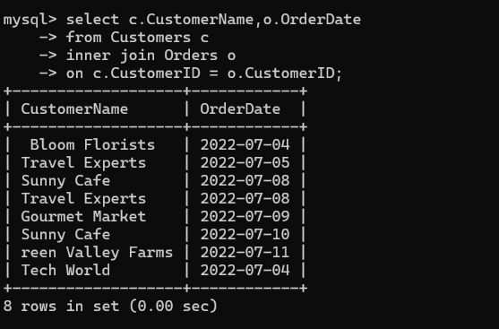Code:

1. Count orders made by every customer and display the customer Id from customers and the number of orders made by them. Arrange the table in ascending order.

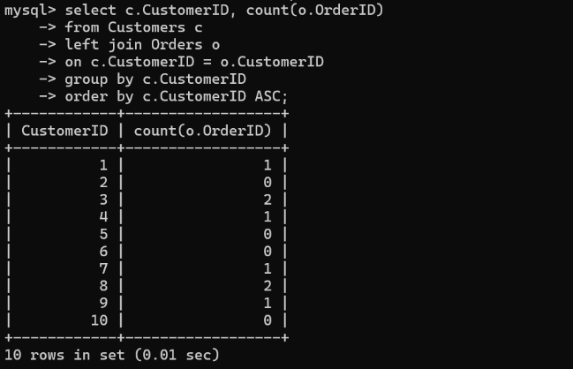Code:

1. Display the customer Id from customer table who made more than one order. \

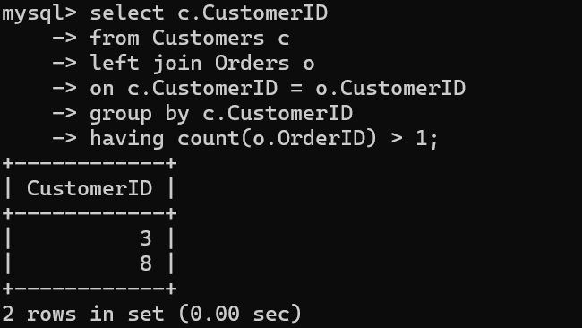Code:

**Discussion:**

SQL JOINs play a crucial role in handling relational databases by combining related data from multiple tables. In a **customer order management system**, JOINs simplify retrieving structured data:

* **INNER JOIN**: Find customers who placed orders (it check both table related data).
* **LEFT JOIN**: Show all customers, even those without orders(only get left table related data).
* **RIGHT JOIN**: Display all orders, including those without customer details(Only get right table related data).
* **CROSS JOIN**: Generate all possible customer-product combinations for marketing analysis.

JOINs optimize queries, improve efficiency, and reduce redundant data processing, making them essential for real-world applications like e-commerce, finance, and customer management.